Code Club Scratch Resources
If you are looking for activities that are most involved than the Scratch Card Lessons ( https://scratch.mit.edu/ideas ) you might be interested in the Code Club Resource: https://www.raspberrypi.org/magpi-issues/CC_Book_of_Scratch_v1.pdf
With the move to Scratch 3.0 (January 2019) all resources have not caught up to the changes. As mentioned, Scratch Cards are still useable and represent a great way to get started. I continue to use them with any new coding club students. The key items – the block remain the same and students do not seem to be confused by the differences in the parts of the main screen. This PDF file uses Scratch 2.0.
The activities in this book cover the basics and then go on to more challenging coding. The organization of the information on the pages is much ‘busier’ than that of the Scratch (and ScratchJr) cards. The layout reminds me of a magazine page rather than an instruction/direction page. It may or may not be a hurdle for some students.
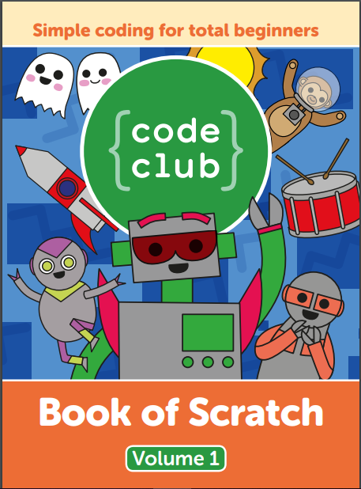
Besides the instructions there is a link for other Club Code projects at the Raspberry Pi Foundation site: www.rpf.io/ccprojects as well as the .sb2 files for all the projects included in the PDF (Scratch 2.0 version files) at www.rpf.io/book/s1-assets (these .sb2 files will run in Scratch 3.0). The first section of the PDF reviews the various elements of Scratch, but since it is examining Scratch 2.0 it is not necessary to refer to those pages.
The instructions are clear and illustrated. There are How To’s, Tips, and Challenges that provide for a side range of coding abilities. The last page gives additional ideas for more projects based in the information learned.
Rock Band (pages 24 to 36) learn about: Event Blocks and Sound Blocks; the concept of sequencing; how to edit sounds; and how to make changes to sprite costume.
Lost in Space (pages 38 to 48) learn about: co-ordinates and direction (angle degrees) and how to use loops for animation.
Ghost Catcher (pages 50 to 61) learn about: how to use random numbers and locations; variables and how to add keeping score to project; and how to add a timer. Additional ideas are: voting project, pick a player, and random art generator.
Chatbot (pages 62 to 73) learn about: If and If/Else blocks; If/Else situations for varied ‘answers’ give to Chatbot; Ask and Join blocks; and Make a Variable. Additional ideas are: quiz, guessing game, and paint app.
On Target (pages 74 to 91) learn about: target shooting game; learn about co-ordinates within 4 quadrant grid; make x- & y- coordinate variables and include Slider; add Score when target is hit and then different points within target; and random move of target. Additional ideas are: sliding ghosts, grid plotter, and falling rocks.
Boat Race (pages 92 to 103) learn about: colour sensing collusion detection; sprite follows mouse pointer; sprite stops at maze borders; edit boat sprite costume to appear ‘broken’; add trial timer; add boost spots to maze (boat moves faster); add a gate to maze; add additional player; and add additional levels. Additional ideas are: archery, poetry generator, and beat the goalie.
Useful Code (pages 104 to 109) snippets of code to make a feature (from spinning sprite to count down timer)

