Changes from 2.0 to New 3.0
Note: this file is Landscape Orientation to show screen shots of 2.0 and 3.0 side-by-side.
First off here are the items that are not yet active for Beta 3.0:
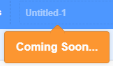
You are unable to title your project yet (if you click Untitled a 2nd time you get the next message and if you do it a 3rd time this last message!)
You can title it when you download it to your own computer 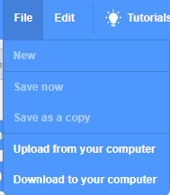 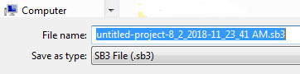 like you would any other file.
Also and Sharing your project to the Scratch Community, My Stuff, or Logging in to your account are not active. You can still access all these features if you work in 2.0.
does not take you back to the Main Scratch page.
is not available 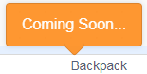 is not available
What IS active
Clicking on this takes you to … https://scratch.mit.edu/discuss/topic/299791/
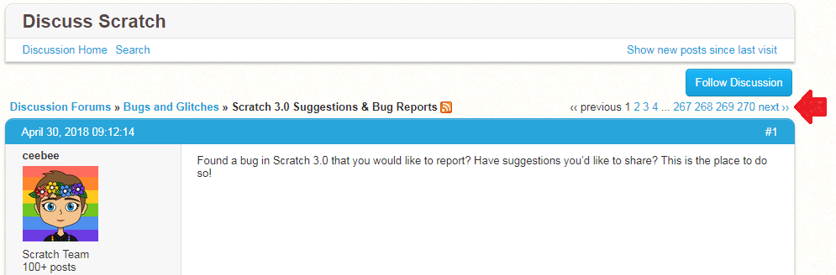
You can read the comments of others or add your own!
Translate is active 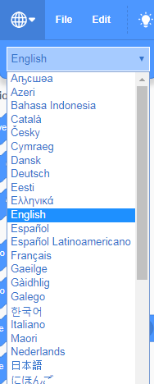 but also remember the Google Translate is a new extension as well.

Tutorials takes you to …
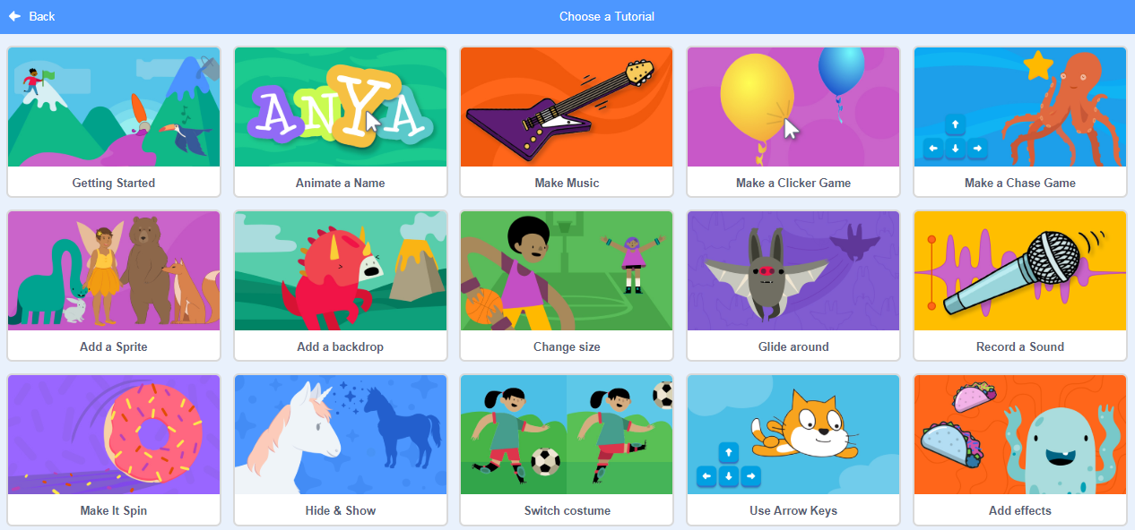
and replaces 2.0 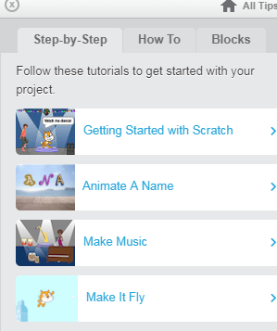 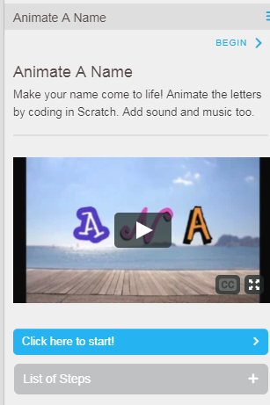 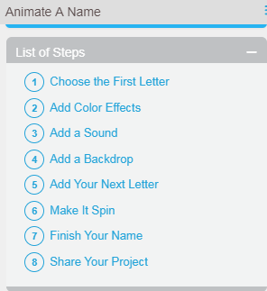 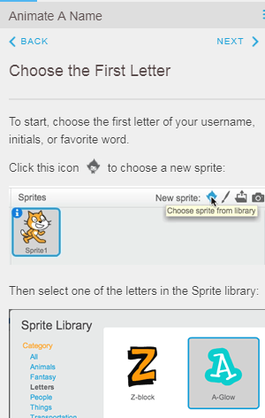 etc.
Picking one Tutorial and you are immediately returned to the Project screen and the Tutorial appears.
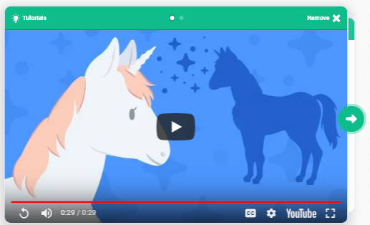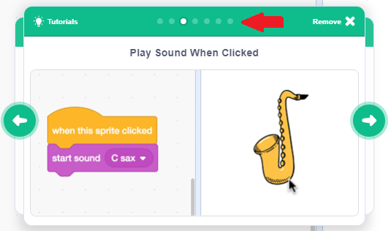
It can be picked up and moved around the screen to a spot that is best for you (for example, doesn’t cover your blocks). There is a short video (in English) and depending on the Tutorial other slides (such as this one 2nd of 5 slides for Make Music Tutorial, note the # of dots is the # of slides)

Clicking the Green arrow on the Right to the last slide lists other Tutorials that might be useful.
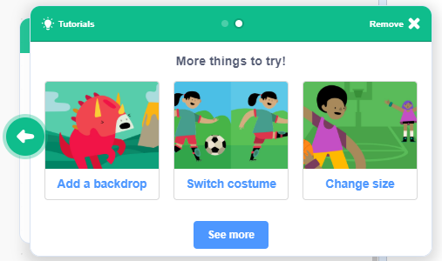

What’s New, Different, or Moved Around
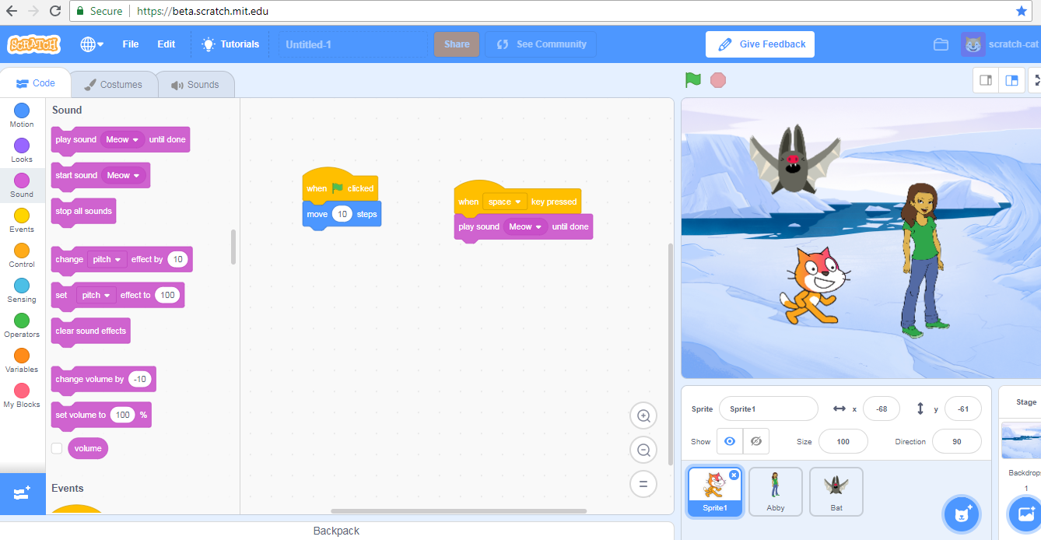

The centre panel of coding, costumes and sounds has moved to the left hand side of the screen. The Stage has moved to the right hand side of the screen.
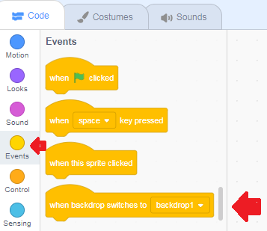
Now there are two ways to get to the blocks you want. Click the buttons on the left hand side or move the slider bar on the right hand side.
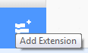At the bottom is where you can add the extensions you want.
3.0 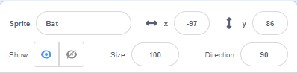 Replaces and
3.0 adds Show and Hide Sprite
3.0 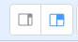 Replaces 2.0 shift smaller stage size and larger coding blocks area and gives 2 choices of size rather than just one

Costumes looked like this and now looks like this
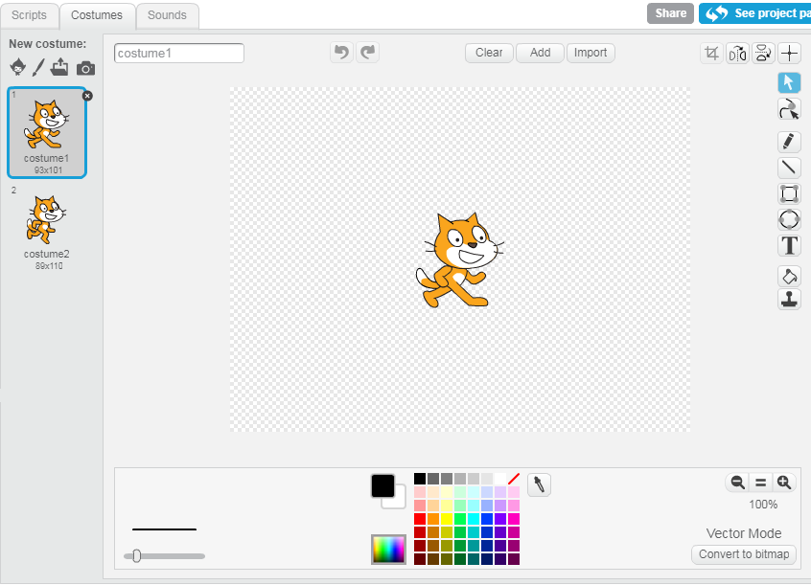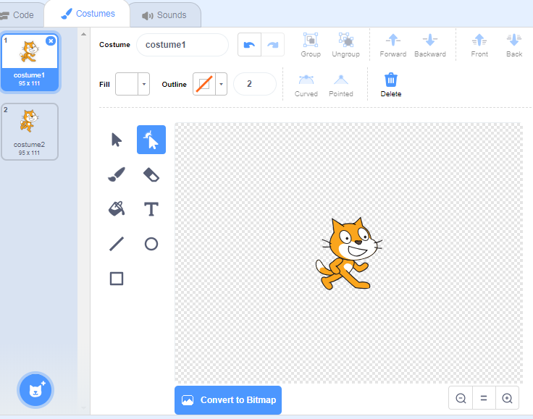
Fill is ↓ and ↓ Outline is ↓
2.0 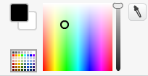 replaced by 3.0 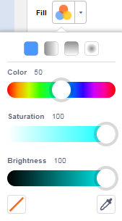 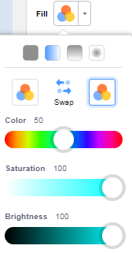 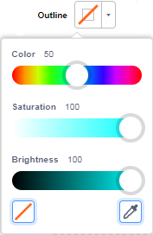
Sounds looked like this and now look like this
2.0 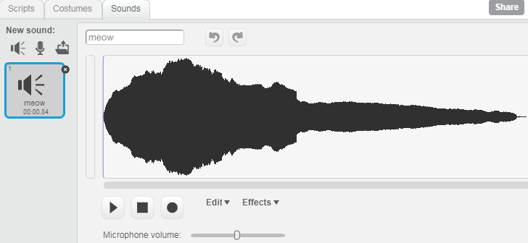 3.0 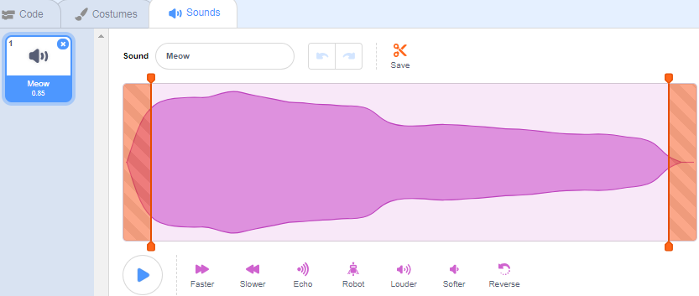
3.0 These buttons replace 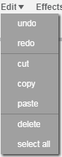 and 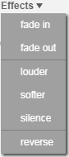
3.0 This 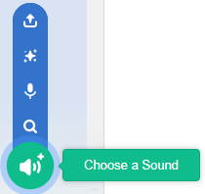 replaces 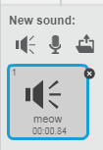 with being a random sound selected for you.
Sprites looks like this and now looks like this (with the ability to SEARCH for a sprite added!)
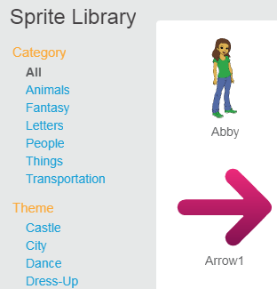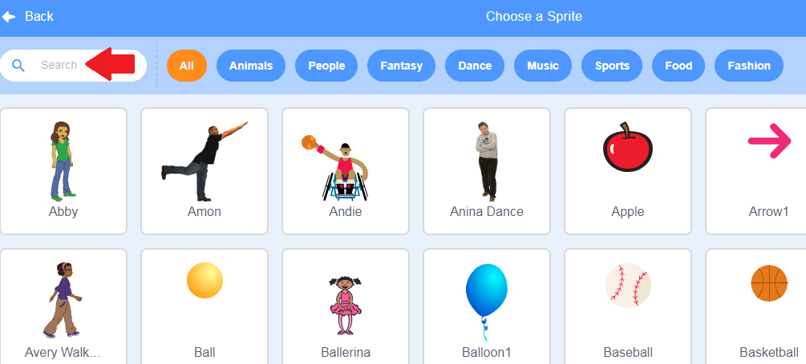
2.0 just said how many costumes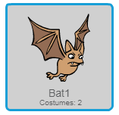 3.0 shows you them (hover over sprite)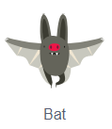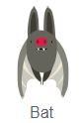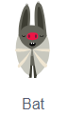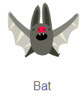

3.0 This 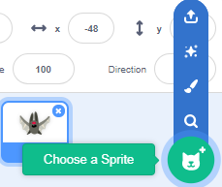 replaces with being a random sprite selected for you.

Backdrops looked like this and now they look like this (with the ability to SEARCH for a backdrop added!)
2.0 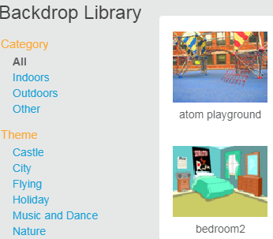 3.0 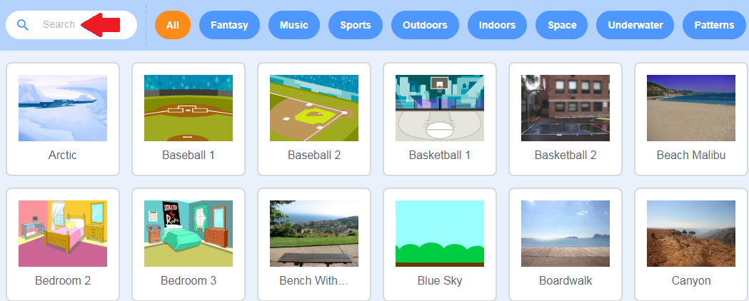
2.0 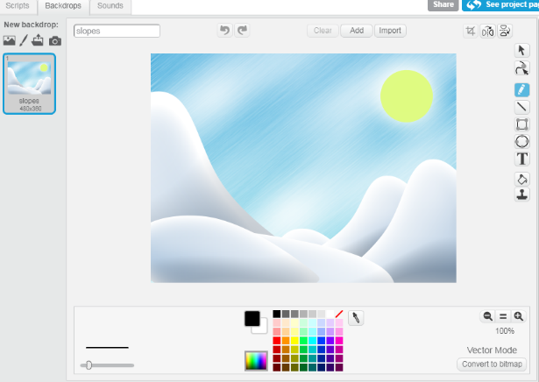 3.0 