Canadarm 2

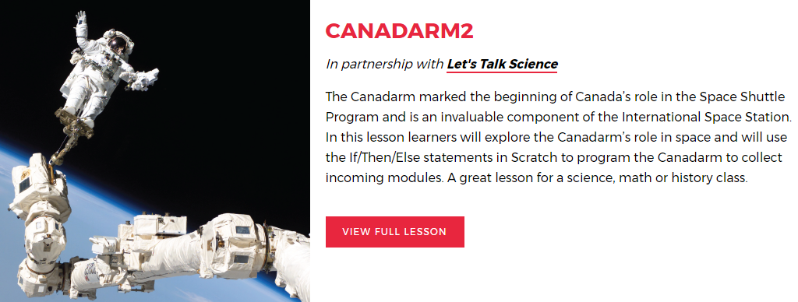
Canada Learning Code Channel (where you will find all Introductory Videos, Lesson Tutorials, and a Terminology Tutorial) This channel is always updating the videos so check in here if the file of your project does not contain a Lesson Tutorial or On-line Chat Recording. https://www.youtube.com/channel/UCGe1pjWRuqXDMp2WbZjbrWQ
In preparation for this project here are the links to the Canadarm Information:
Part of the Introduction Section has a link to Chris Hatfield using the Canadarm2 http://www.asc-csa.gc.ca/eng/search/video/watch.asp?v=1_naxnvgtb&search=canadarm
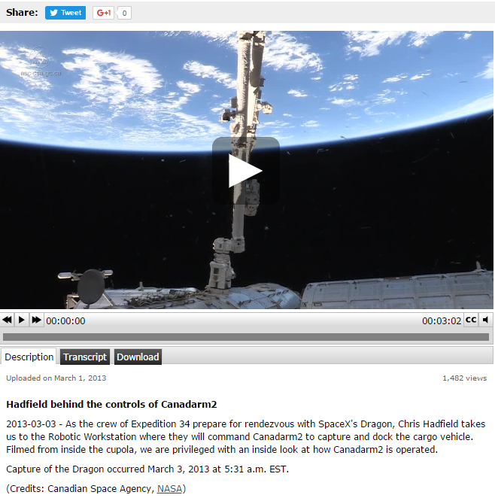
Part of the Extension section of the lesson refers to a 3 minute video titled, The Canadarm: Celebrating 30 Years of Success (November 14, 2011) https://www.youtube.com/watch?v=oMSctD2PNaI
Here are some of the YouTube videos regarding Canadarm, not mentioned in the lesson:
3 minute publicly video on 10th anniversary of Canadarm April 11 2011
https://www.youtube.com/watch?v=BEK6uGuV83g
6 minute Did You Know? Video – The History of the Canada Space Agency March 18 2014
https://www.youtube.com/watch?v=eJmfOdiiVCc
3 minute video Hatfield behind the controls of Canadarm 2
https://www.youtube.com/watch?v=K7NvsxcoDKo

There are two Videos for this project
15 minute Project Video for teacher to watch in preparation to explain Project https://www.youtube.com/watch?v=hwe7bNGGPM0
This video was a production video and Jessica Duarte explains the steps. It was recorded on April 3, 2017. You will notice some changes in the coding on this video, the hour long live training video, and the instructions posted at CLC. They aren’t major changes just the result from working on a project over time and having groups of people examine the coding and offering different ways of achieving similar results.
Here is a short summary by times of the video so that you may decide to show parts of it to your students.
0:00 – 1:00 quick intro explaining the goal of the project
1:00 – 3:35 explaining and showing which blocks to use to move Canadarm Up, Down, Left, & Right
3:35 – 14:46 explaining and showing which blocks to use to get Canadarm to close around Shape Module, for the Canadarm & Shape Module to travel to the Shape Port, for the Canadarm to open, for the Shape Module to stay in the Shape Port, and finally to reset the position of all three shapes with X- & Y- coordinates.

60 minute Webinar for teacher to watch in preparation to explain Project https://www.youtube.com/watch?v=jBDCaMN9J1o&feature=youtu.be
This video is a live training session that took place May 26, 2017. Again, you will notice some changes in the coding on this video, the 15 minute training video, and the instructions posted at CLC. They aren’t major changes just the result from working on a project over time and having groups of people examine the coding and offering different ways of achieving similar results. Also with this YouTube Ms. Duarte is answering questions from teachers participating in the Webinar so that’s why it is longer.
If you are stuck for time and are familiar with Scratch the 15 minute video should do.

There are two Scratch projects for the Canadarm.
The first one is a completed project and is titled Canadarm 2 - Final. Show this to the students so they can see how the arm works. Use the four direction arrows on the keyboard to move the arm around and the space bar to open and close the arm. From viewing or actually “playing” the project students can begin to understand the goal of the project, the actions of the arm and what they need to code to complete those actions.
Giving the students access to this projects means they can have the choice of checking out the coding by clicking on the See Inside button. 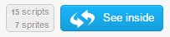 located at the upper right hand corner of the screen. They can also view the Remix Tree and “play” any of the Remixes shared.
With this version students can make simple changes to the coding such as changing the number of pixels the arm moves each time an Arrow Key is clicked or change the location of the Shape Modules in space.
If you have a Teacher Account this project can be loaded in a Class Studio for students to view without typing the 9-digit Project identification number.
Scratch Canadarm 2 - Final, https://scratch.mit.edu/projects/152052443/
The second project is the Starter/Initial project. This is the one that has the Backdrops and sprites but no coding blocks. With this students can follow the step-by-step instructions or work completely on their own or a combination of both written instructions and independent coding.
Scratch Canadarm 2 Starter/Initial Project Link, https://scratch.mit.edu/projects/153481885/
