Beginning Project Coordinate Plane Projects Lesson
Inspirations & Connections
http://mathies.ca/learningTools.php
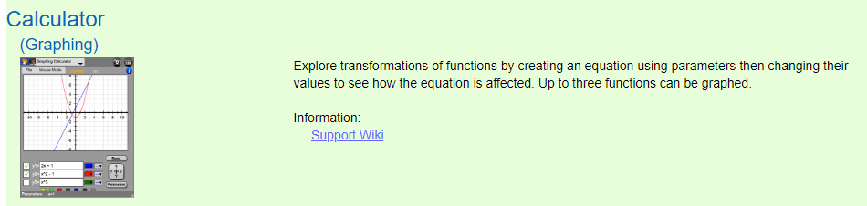
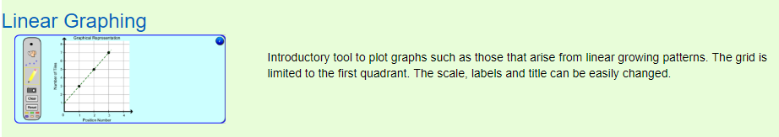
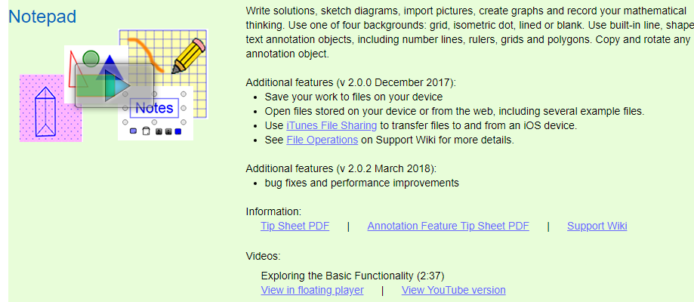
http://mathies.ca/files/Grade%205%20Geometry.pdf
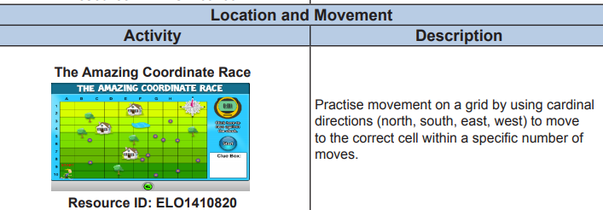
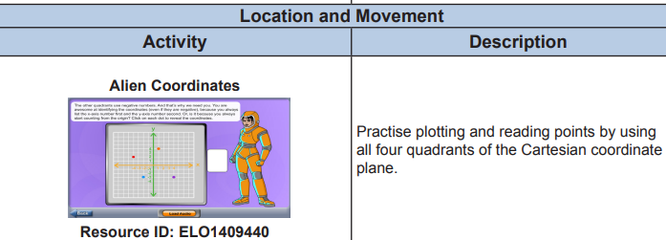

https://scratch.mit.edu/projects/115533601/
Pose this question. What coding do I need to have Scratch move to the same coordinates in all four quadrants (x, y), (-x, y), (x, -y), and (-x, -y)?
Add this challenge. What blocks would I need to have Scratch draw the resulting shape?
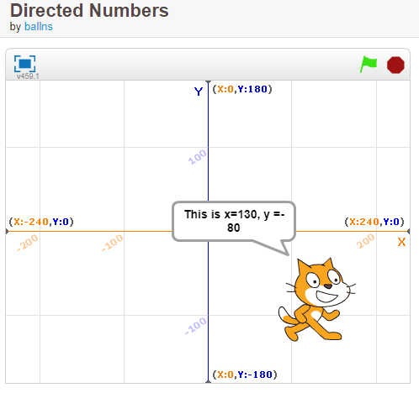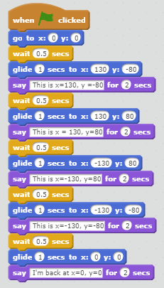
https://scratch.mit.edu/projects/111064887/ This project adds animation.
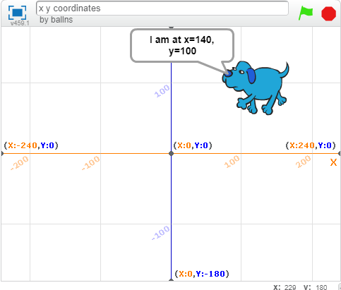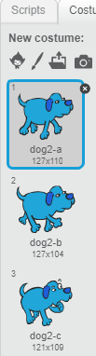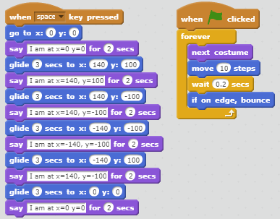

https://scratch.mit.edu/projects/173102/ https://scratch.mit.edu/projects/601498/
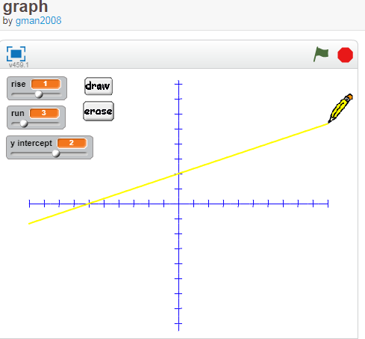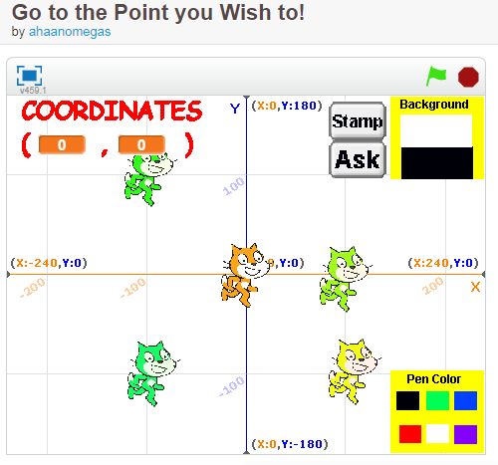
Coordinate Plane Lesson Plan SratchEd Info
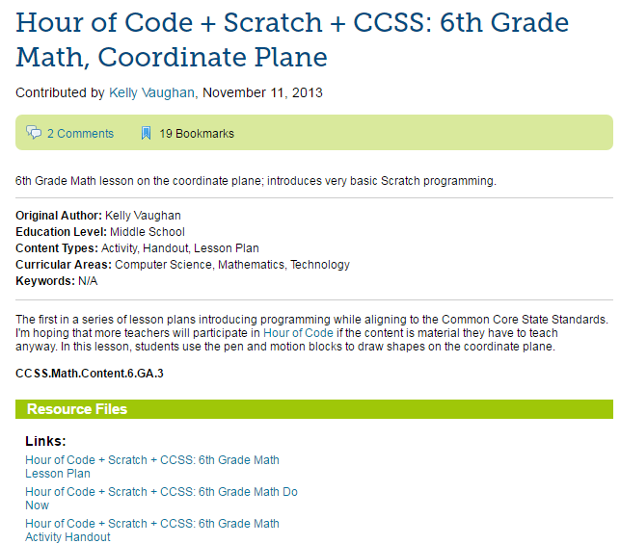

http://scratched.gse.harvard.edu/resources/hour-code-scratch-ccss-6th-grade-math-coordinate-plane

Lesson Plan
https://docs.google.com/document/d/17t-6RsoqhzOdiHTkAfKih8q1Jr-pXXQYG4EAabAO818/edit

Coordinate Plan Warm Up
https://docs.google.com/document/d/1HVRhzeKnmFct9Fzs-PiivOe2DNFHS4HWZ6q5BTvXs_8/edit
Activity
https://docs.google.com/document/d/1MQ2AhjvmB_QPkNmdac_UYQXIKd_Bk7hZFAK0tdFVDLU/edit

Grade 6 Math Scratch Lesson: Using Coordinates for Coding
I found this lesson at ScratchEd (http://scratched.gse.harvard.edu/)
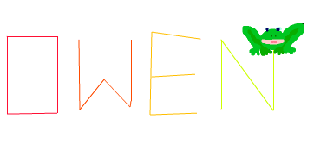

The project involves coding the letters of your name so that the Sprite “spells” the name. It requires the correct directional movement of the Sprite, the correct angles for turns, the motion of the Pen up or down and changing the pen’s colour. Extensions for this project will lead to drawing of geometric shapes and real world objects.

Along with the instructions there is a You Tube video. It is for the teacher to view rather than the students. https://www.youtube.com/watch?v=JZtYD4svnhA&feature=youtu.be&hd=1
Here is the sample project that students can view or remix. I think, in this case, remixing is not necessary. I think this is a good project to have the students to code all the blocks themselves because their names are different and in the end it will be faster to set their own co-ordinates than to fiddle with the co-ordinates in preexisting blocks. https://scratch.mit.edu/projects/18174532/#editor
There are three elements to consider before tackling this project. One, understanding the Pen blocks (see Preparation A); two, understanding the + & - values of X & Y in the four quadrants (see Preparation B); and three, coding using blocks to successfully draw the letters (see Preparation C).

Preparation A: For the task students should learn to use the Pen blocks if the students are not familiar with them. Also the Artist at Hour of Code (https://hourofcode.com/art ) is a good companion task. Students could complete the 9 puzzles levels before or after and Puzzle level 10 is when they can make their own designs. It is an excellent example of how Math, Coding, and Art blend together. I believe that the Artist program offers students the most creative set-up for students and yet it is used the least. On its own it would make a great art task and the results printed with a colour printer.
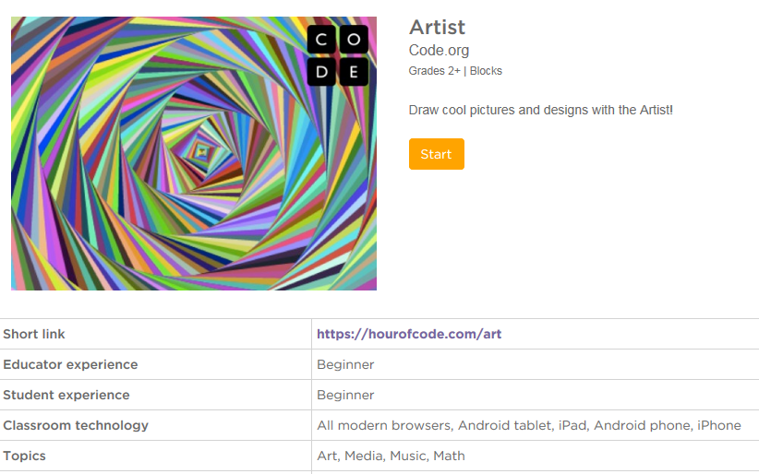
Here is a sample of the blocks used in Artist. The idea of the pen and movement by pixels are used here. The shift to X & Y co-ordinates adds to a more exact location within the screen grid.
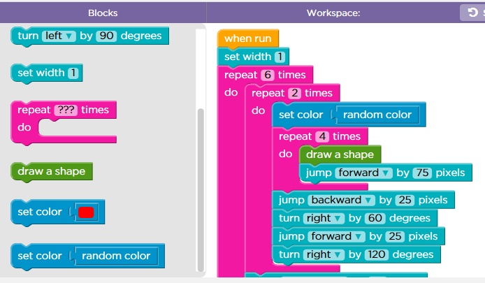

Other extensions: Instead of letters, students could code a series of polygons for the Sprite to draw. This extension would suit the Grade 6 curriculum expectation: Name constructs polygons using coding in Scratch, given angle and side measurements (e.g., his/her Scratch Project used to draw trapezoids with a 45° angle and sides measured in pixel steps).

Green Pen blocks
Clears all printed and drawn-by-a-pen blocks on the stage.
Prints an image sprite on a scene. On a scene, not on a backdrop. It is possible to change backdrops.
Pull down the Pen. After this command all actions with a Pen will be accompanied by a line on a stage.
Move the Pen Up. After this command an action with Pen will not leave any traces on a stage.
Set Pen color. The color choice can be made using the cursor.
Change the pen color to 10. The change of color is the same as "color effect".
Set Pen color in according to the table of colors.
Change Pen shade by 10 %.
Set Pen shade to 50%.
Change Pen size by 1 pixel.
Set Pen size to 1 pixel.

Preparation B: For the task students should understand the positive and negative values for X & Y for each quadrant. I have printed off a page with the co-ordinates labelled and a blank grid. Have the students locate different co-ordinate pairs in each quadrant (+X, +Y), (+X, -Y), (-X, -Y), and (-X, +Y).
There is a project that explains the four quadrants. It also gives students a chance to see the coding needed to move the sprite to various locations. https://scratch.mit.edu/projects/2903229/
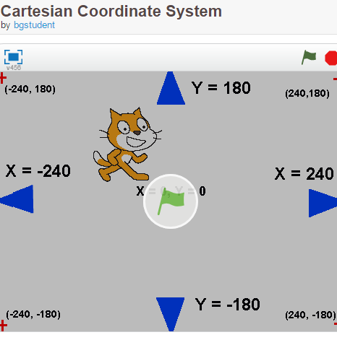
Preparation C (optional): Depending on the number of previous coding experiences of the class it might be beneficial to use the think aloud strategy and make a general plan of the code required for one letter. Do the students understand the idea of providing blocks (coding) for each action of the sprite? Unplugged activities such as the My Robotics Friends by Thinkersmith might be useful. My Robotics Friends has students giving other students (robots) commands to stack red solo cups in various configurations. Another task might have the teacher or a student act as a robot and follow the commands exactly as given by other students to draw a letter.
Activity:
Explain the goal of the project to the class.
Play the sample project for the class.
Draw a letter on the numbered grid & draw students’ attention to key start and end points for each line that makes up the letter.
Develop a set of instructions (A, see below) to draw a letter. Perhaps the teacher or a student acts out the coding and draws a letter. This should demonstrate ‘errors’ in the coding because the robot can’t draw the letter properly.
Show a part of the coding (B). Have students “read” the blocks. For example: “When the green flag is clicked the stage area is going to be cleared of any lines. The pen is up – I think of the fact that if the pen is up away from the paper no ink comes out on the paper. I don’t want a line from where the sprite is to where the starting point of the letter is. I decide what colour “ink” I want. I have the sprite glide or go to the X,Y position to start to draw. I put the pen down so when the sprite moves a line will appear. I have the sprite glide or go to the end of the line position. I have the sprite go to three other positions on the grid and I make an O. I pick the pen up so the sprite moves without leaving a line. I have the sprite go to the start position of the next letter. I start to code that letter.”
Write the instruction guidelines and post them for reference (C) (see chart).
Use the attached Checklist and Reflection sheet to guide the work.
For example:
(A)A first time effort might look like this: | (B)A section of the blocks used in the sample project | Another draft developed with the benefit of seeing the blocks.
● The Sprite begins at the starting point.  ● The Sprite draws the first line that make up the letter.  ● The Sprite turns.  ● The Sprite draws the next line.  ● The Sprite repeats until the letter is done.  ● The Sprite starts the next letter.  ● The Sprite repeats until all the letters are done. | 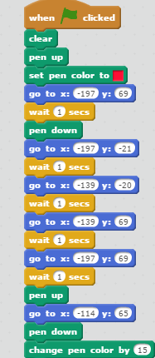 | ● Start by clearing the stage of any lines.  ● For the Sprite to move to the starting point of each letter the Pen must be in the Up position.  ● The colour of the letter must be set.  ● The starting position must be identified with X & Y co-ordinates.  ● The pen must be in the Down position.  ● The end position of the first line must be identified with X & Y co-ordinates.  ● The end position of the next line must be identifies with X & Y co-ordinates. And so on … depending on the number of lines needed to draw the letter.  ● When the letter has been drawn the Pen must be in the Up Position.  ● The Sprite must go to the starting position of the next letter.

Checklist and Reflection Name: _ _ _ _ _ _ _ _ _ _ _ _ _ _
_____ Used the 4 Quadrant paper to design the letters of your name
_____ Used straight lines only when designing the letters of your name
_____ Used some curved lines along with straight lines when designing the letters of your name
_____Transferred the X & Y co-ordinates from the paper draft to the block in Scratch
_____ Selected a sprite to draw the letters
_____ Added a background from Scratch

_____ Used the 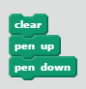 pen blocks properly so there were no extra lines in the project (for example: joining one letter to the next.
_____ Used different colours for each letter by using 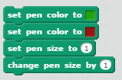 pen blocks correctly
_____ Spaced out the letters evenly across the stage using more than one quadrant
_____ added information on the Project Page for Notes and Credits
Additional features:
_____ Added your own background from the Internet or camera
_____ Created your own background (using Backdrops Tab)
_____ Added your own Sprite from the Internet or camera
_____ Created your own Sprite (using Costumes Tab)
What about your project do you want me to notice? _ _ _ _ _ _ _ _ _ _ _ _ _ _ _ _ _ _ _ _ _ _ _ _ _ _ _ _ _ _ _ _
_ _ _ _ _ _ _ _ _ _ _ _ _ _ _ _ _ _ _ _ _ _ _ _ _ _ _ _ _ _ _ _ _ _ _ _ _ _ _ _ _ _ _ _ _ _ _ _ _ _ _ _ _ _ _ _ _ _ _ _
_ _ _ _ _ _ _ _ _ _ _ _ _ _ _ _ _ _ _ _ _ _ _ _ _ _ _ _ _ _ _ _ _ _ _ _ _ _ _ _ _ _ _ _ _ _ _ _ _ _ _ _ _ _ _ _ _ _ _ _
What problems did you have with your coding? How did you debug them? _ _ _ _ _ _ _ _ _ _ _ _ _ _ _ _ _ _ _
_ _ _ _ _ _ _ _ _ _ _ _ _ _ _ _ _ _ _ _ _ _ _ _ _ _ _ _ _ _ _ _ _ _ _ _ _ _ _ _ _ _ _ _ _ _ _ _ _ _ _ _ _ _ _ _ _ _ _ _
_ _ _ _ _ _ _ _ _ _ _ _ _ _ _ _ _ _ _ _ _ _ _ _ _ _ _ _ _ _ _ _ _ _ _ _ _ _ _ _ _ _ _ _ _ _ _ _ _ _ _ _ _ _ _ _ _ _ _ _
Possible Report Card Comments
There are no qualifier statements with these comments.
From the Grade 6: Mathematical Process Expectations

PROBLEM SOLVING
Name develops, selects, and applies problem-solving strategies as she/he poses and solves problems and conducts investigations when he codes in Scratch (for example his 4-Quadrant Name Project) to help deepen his/her mathematical understanding.
REFLECTING]
Name demonstrates that she/he are reflecting on and monitoring his/her thinking to help clarify her/his understanding as he/she completes an investigation or solves a problem such as his/her coding in Scratch (for example his 4-Quadrant Name Project). He/ she adjusts the strategies (blocks) used with the debugging strategy and records her/his their thinking in the Scratch project page.

CONNECTING
Name makes connections among mathematical concepts and procedures, and relates mathematical ideas to situations or phenomena drawn from other contexts (e.g., his 4-Quadrant Name Project using Scratch).

REPRESENTING
Name creates a variety of representations of mathematical ideas (e.g., his 4-Quadrant Name Project using Scratch), make connections such as geometric 2-D shape and angles, and applies them to solve problems with his/her coding when he debugs.

From the Grade 6: Geometry and Spatial Sense
Overall Expectations
By the end of Grade 6, students will: describe location in the first quadrant of a coordinate system

Location & Movement: Specific Expectations
Name explains how a coordinate system represents location, and plot points in the first quadrant of a Cartesian coordinate plane when he coded his Write Your Name project in Scratch.

Cat and Fishy Horizontal and Vertical Reflection
https://scratch.mit.edu/projects/104402130/
From Dan Anderson (dan@recursiveprocess.com and @dandersod ) a Power Point Presentation Titled Geometry from Scratch NXTM 2016
Link: https://docs.google.com/presentation/d/1F4qKUAqmMgcTiQNL-bjwvo8ry-DyuJ6ulEHIPV4KdRk/edit#slide=id.g10feba8d6d_0_48
There are no notes for this project. However if the students are given the one set of blocks and the worksheet I made from the coding I think they can complete the worksheet and then the coding to have the reflections in all four quadrants.
