Animate Music Video Links
Just some projects to give ideas for animating music. Some can be remixed and others complex coding so use to generate ideas.
Easy https://scratch.mit.edu/projects/16060091/ no animation, just create background
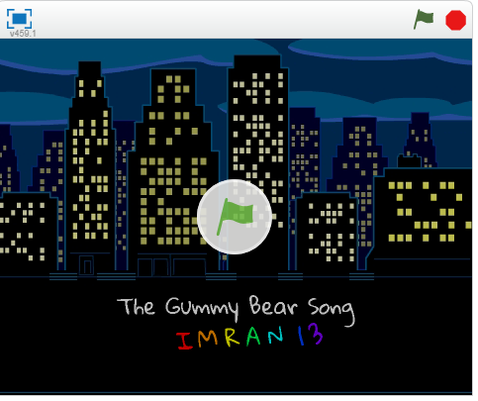
https://scratch.mit.edu/projects/12561093 https://scratch.mit.edu/projects/361149/
This has different background activated by space bar loop of stick figures
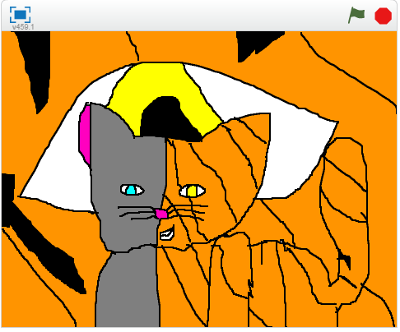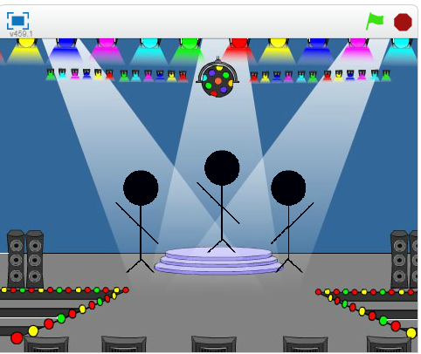

Medium
https://scratch.mit.edu/projects/18554259/ This has animations
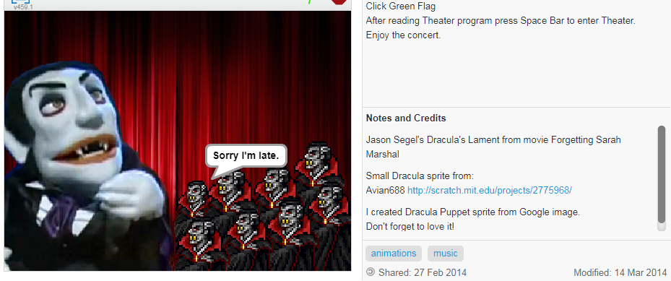

https://scratch.mit.edu/projects/13725397/ https://scratch.mit.edu/projects/15385262/
Several different animations (1 song) Involves some Drawing to make radio front and Buttons are sprites, remix for one’s own songs, additional elements volume (multiple songs)
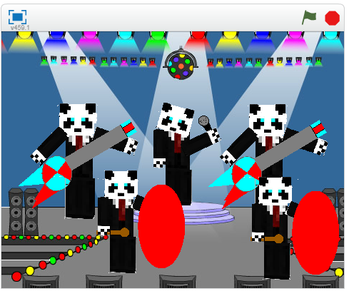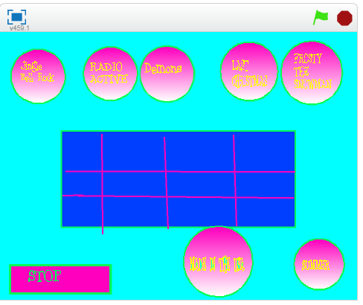
Medium
Add lyrics and background, must advance with music (this one doesn’t) https://scratch.mit.edu/projects/18280508/ 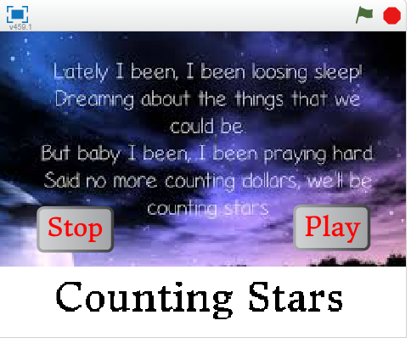
Difficult
Lots of hand drawn aminations https://scratch.mit.edu/projects/14264749/
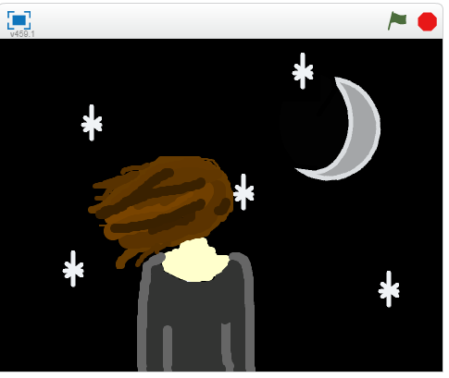
Difficult
Here is a rap of repeated words makes a rhythm pattern. The sprites vary as the rap goes on.
https://scratch.mit.edu/projects/23251066/

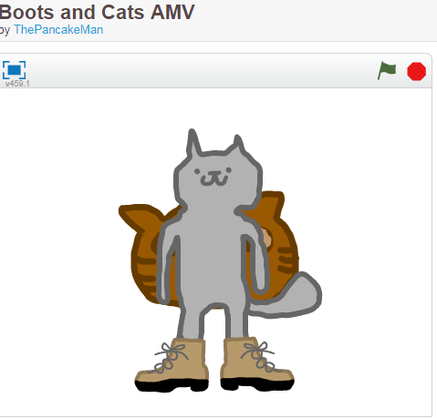
Difficult
This Project has Scratch blocks makes the sounds https://scratch.mit.edu/projects/197669904
