Angles and Protractor Projects Links
https://en.scratch-wiki.info/wiki/Turn_()_Degrees_(blocks) and https://en.scratch-wiki.info/wiki/Trigonometry
And https://en.scratch-wiki.info/wiki/()_of_()_(Operators_block)

https://scratch.mit.edu/projects/16695823/ https://scratch.mit.edu/projects/43101062/
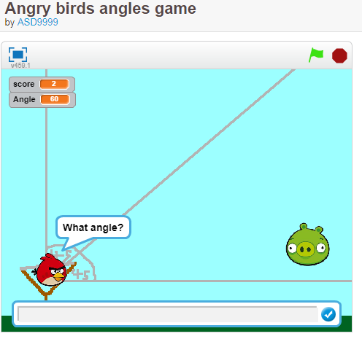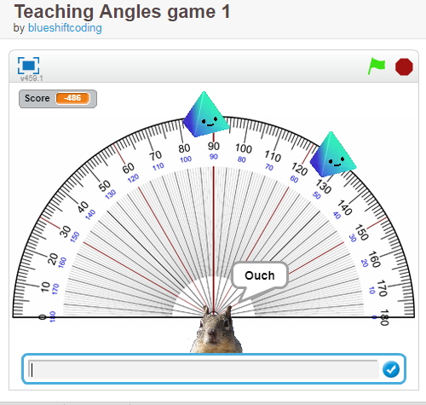

https://scratch.mit.edu/projects/1027734/ https://scratch.mit.edu/projects/23033844/
ray spins around and number of degrees is shown dapontes has over 550+ projects lots of math
Tags: Geometry, mathematics, elementary math
