Algebra Intermediate Links
https://scratch.mit.edu/projects/159986102/
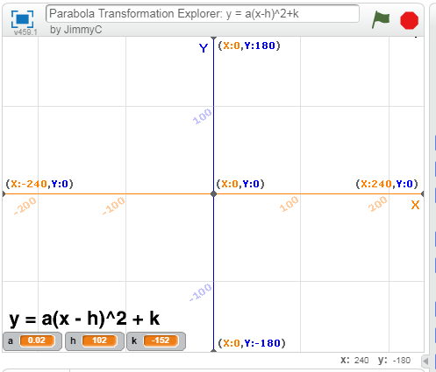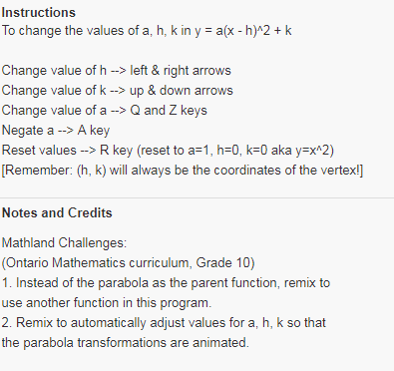
More information here:
http://staff.argyll.epsb.ca/jreed/math20p/quadraticFunctions/quadStandard.htm
Graphing Calculator Projects
https://scratch.mit.edu/projects/96932607/ https://scratch.mit.edu/projects/10637134/ Use to play rather than remix there are 197 scripts and 56 sprites
