A Remainder of One Task:
Lesson Plan
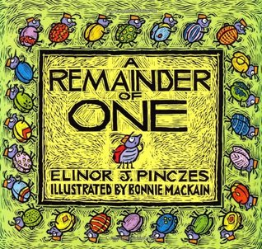
http://kpscobracoders.weebly.com/
Inspiration: Author: Elinor Pinczes & Illustrator: Bonnie MacKain
ISBN: 0-618-25077-8 Publisher: (1995) Houghton Mufflin Co. NY: NY
YouTube Videos of Book reading: https://www.youtube.com/watch?v=Ubm16pTOUhk
& https://www.youtube.com/watch?v=s4zsaoAlMpM & https://www.youtube.com/watch?v=arT7OSEdu3U
Other Resources: Marilyn Burns (Math Solutions) Lesson Plan: https://www.mathsolutions.com/documents/0-941355-46-2_L.pdf
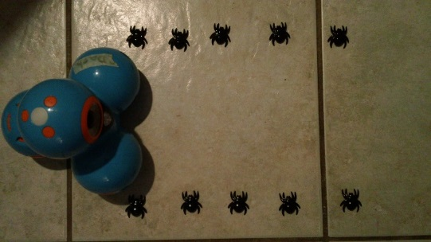
With our DASH lesson for the book A Remainder of One (http://kpscobracoders.weebly.com/0921--0927-workshop.html or more lessons at http://kpscobracoders.weebly.com/dash-and-dot.html ) students laid out the ‘ants’ in an array on the floor and the robot was coded to travel the rows or columns. With ScratchJr the array can be made with objects laid out on a plain background or created in the Draw screen. The Sprite then is coded to move within &/or around the array. By the way, with Scratch and this same idea, students can code the Sprite to draw circles around groups within the array with the Pen Blocks.
There are two ways the array can be used in ScratchJr. One, the easiest is to make it a Background as seen in these two screen shots. On the next page the array becomes a Sprite.
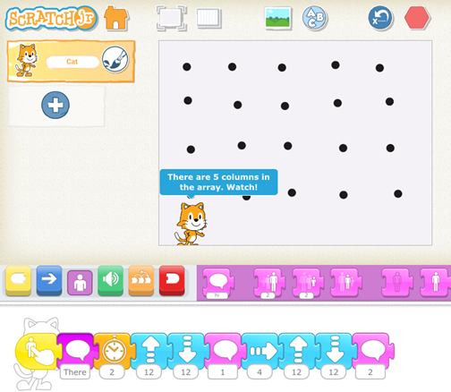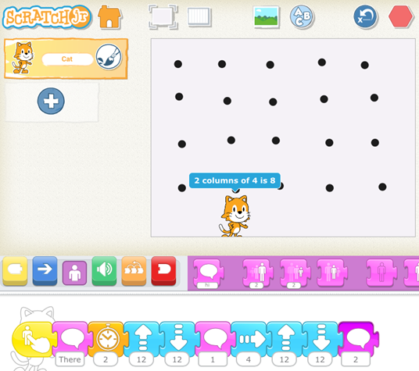
The array of dots was created in the Draw screen as a background. It could have as easily been drawn by the student on paper or ‘ants’ laid out and a photo taken of it with ScratchJr’s camera. The coding has Cat go up and down each column and says “2 columns of 4 is 8 … 3 columns of 4 is 12 …”

The second way to consider an array is to make parts of it as sprites. Here are several examples:
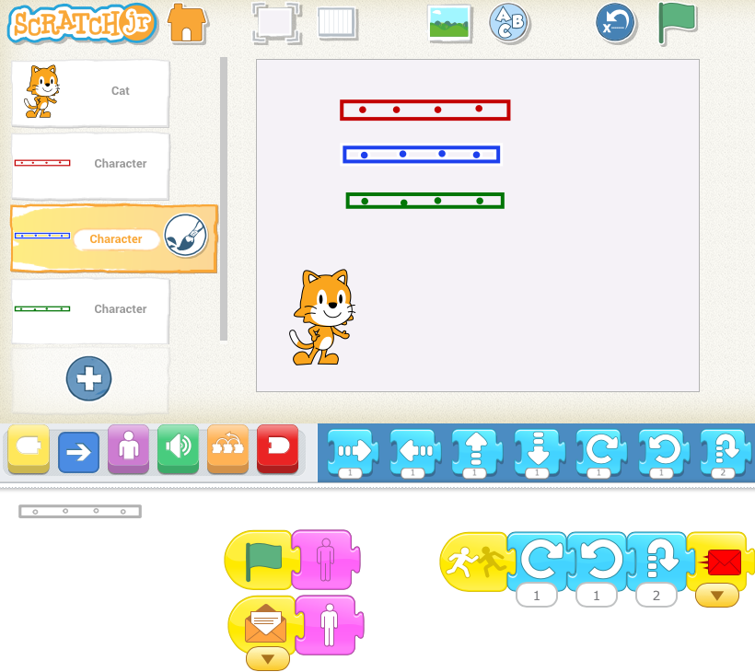
With this screen shot the rows of the array are now Sprites and NOT part of the Background. What is the difference? A Sprite has coding and therefore can do lots of things.
In this case the blue and green array row disappear at the start of the program with the use of the purple Hide block and reappears (purple Show block) after the coding is complete for the red row. When Cat travels up to touch the blue array row (Start on Bump block) it does a little dance and sends a red message to the Cat to say “2 rows of 4 = 8.”

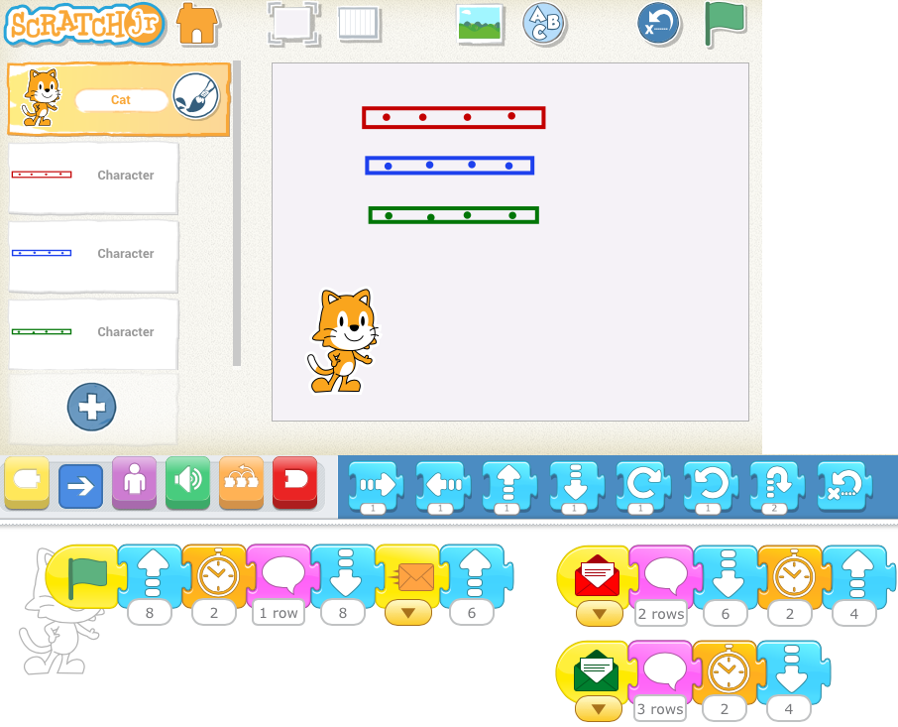
Here is the coding for Cat. It moves up and touches the red array row and says “1 row of 4 = 4” then returns back down to the start position. Cat sends a message (Start on Orange Message block) to blue array row to appear (purple Show block) and travels up to touch it. After the blue array row does a little dance it sends a message (Send Red Start Message block) to Cat to say “2 rows of 4 = 8” and then the coding is repeated for the green array row.
With the array rows as Sprites they interact with Cat and present more challenges for a student to code and debug, when needed.

http://kpscobracoders.weebly.com/

A Remainder of One Task:
Mathies Connections
http://kpscobracoders.weebly.com/
Mathies website: http://www.mathies.ca/learningTools.php
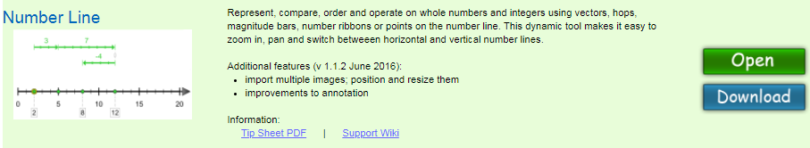
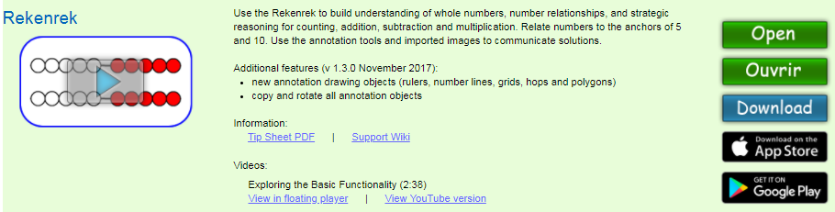
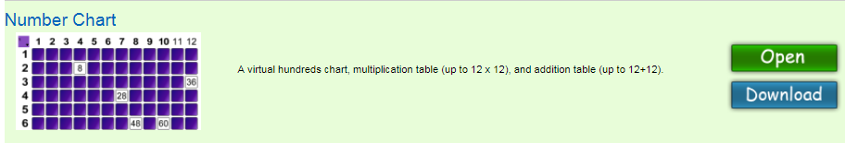
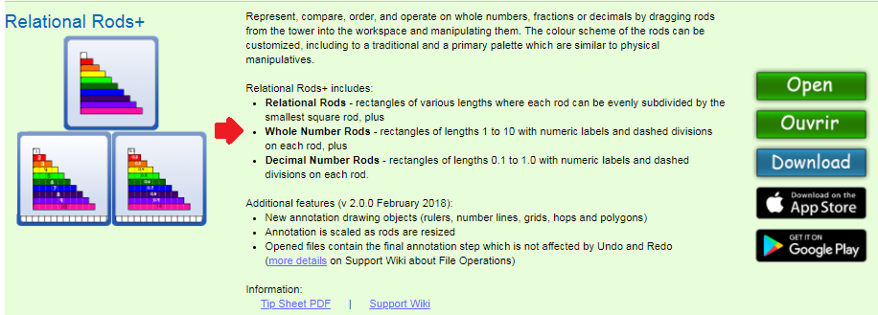

A Remainder of One Task
http://kpscobracoders.weebly.com/
An Array as a Background
Decide on an array.
Make it and take a photo of it as a background or draw it right in ScratchJr.
Decide what your will code. For example,
Will you have the Cat show the rows and columns and talk about them?
Will you have correct and wrong addition, subtraction, multiplication, or division number sentences as Sprites and let your player pick the correct ones? For example:
● ● ● ● ● ●
● ● ● ● ● ●
● ● ● ● ● ●
 | 6 X 3 = 18 | 18 ÷ 3 = 6 | 3 + 3 + 3 = 18 | 18 ÷ 6 = 3

What else can you code?

An Array as Sprites
Decide on an array and if you will have row parts or column parts.
Make Sprites for the parts.
Decide what you will code. For example,
Will you have the Cat and Sprites interact together?
Will the Sprites move around to form an array?
What else can you code?

A Remainder of One Task:
Curriculum Expectations

Grade 3: Number Sense and Numeration
Overall Expectations
By the end of Grade 3, students will:
• solve problems involving the addition and subtraction of single- and multi-digit whole numbers, using a variety of strategies, and demonstrate an understanding of multiplication and division.

Operational Sense
By the end of Grade 3, students will:
– relate multiplication of one-digit numbers and division by one-digit divisors to real life situations, using a variety of tools and strategies (e.g., place objects in equal groups, use arrays, write repeated addition or subtraction sentences) (Sample problem: Give a real-life example of when you might need to know that 3 groups of 2 is
3 x 2.);

Grade 4: Number Sense and Numeration
Overall Expectations
By the end of Grade 4, students will:
• solve problems involving the addition, subtraction, multiplication, and division of single- and multi-digit whole numbers, and involving the addition and subtraction of decimal numbers to tenths and money amounts, using a variety of strategies;

Operational Sense
By the end of Grade 4, students will:
– multiply two-digit whole numbers by one-digit whole numbers, using a variety of tools (e.g., base ten materials or drawings of them, arrays), student-generated algorithms, and standard algorithms;
– divide two-digit whole numbers by one digit whole numbers, using a variety of tools (e.g., concrete materials, drawings) and student-generated algorithms;

